**Autonomous Rover Setup for Huff Research Group**

There are three autonomous rovers used by the members of Huff Research Group. All three rovers have similar configurations: they can be driven manually using a transmitter or given waypoints for them to autonomously cycle through.

The physical setup of these rovers have a number of components, identified in Figure 1.

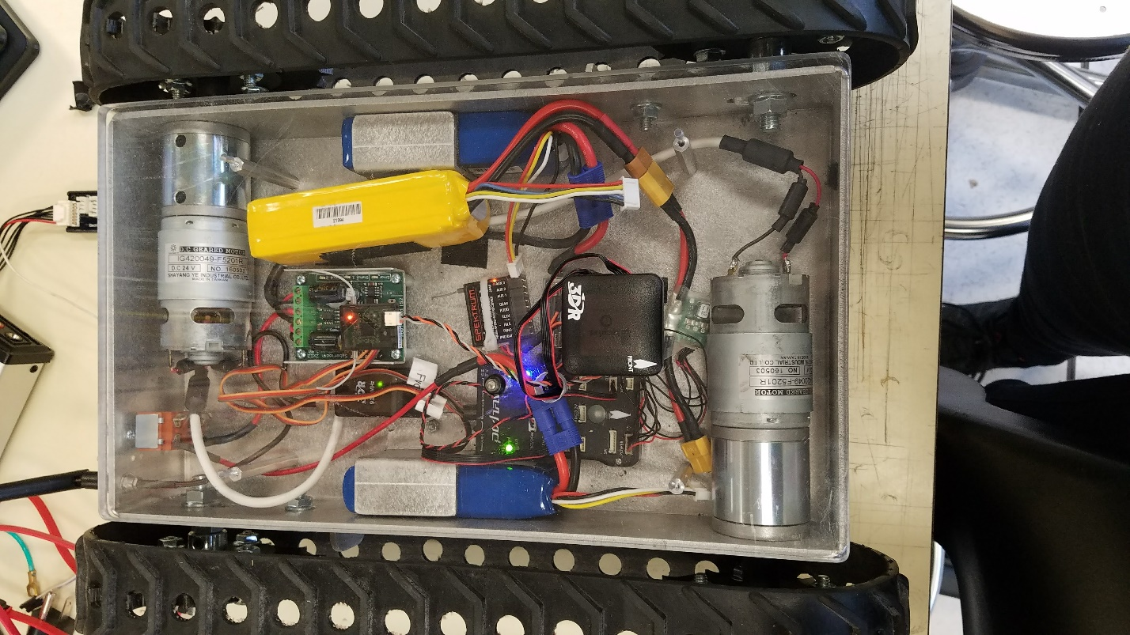

Control Battery

Receiver Antenna

3DR Antenna

Motor Batteries

Receiver

Arming Switch

GPS Antenna

Pixhawk

Motors

Figure : Smallest Rover Components

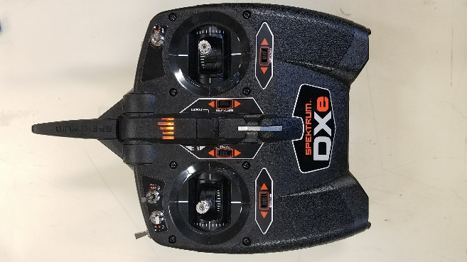While these rovers are highly useful tools for data collection, it can be difficult to get them going because the pixhawk requires a very specific startup sequence. The following procedure will successfully get the rover going with manual control through the transmitter, shown in Figure 2.

**How to setup the autonomous rovers in Huff Research Group:**

1. Turn on the transmitter with the throttle (left joystick) set to the middle. The Spektrum logo should glow orange, as in Figure 2.
2. Plug in all three batteries: Start with the two blue ones, which power the motors, and end with the control battery (yellow), as labeled in Figure 1.

Figure : Transmitter

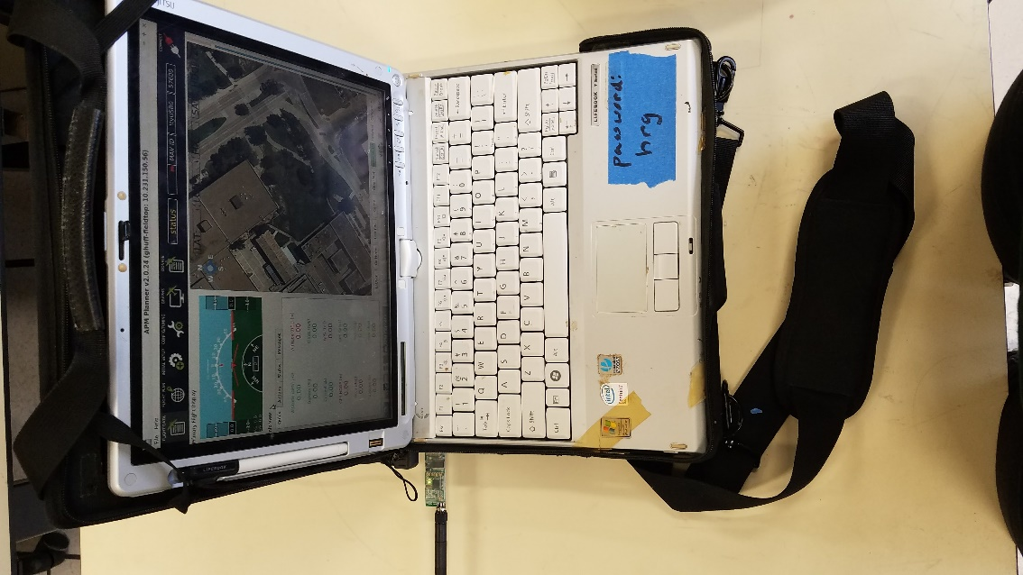

APM Planner Software

1. Wait for the pixhawk indicator light to start flashing blue, if in a GPS-denied environment, or green, if GPS lock is available.
2. Start APM Planner on the laptop. Plug in the 3DR radio to the USB port, as shown in Figure 3.

3DR Radio

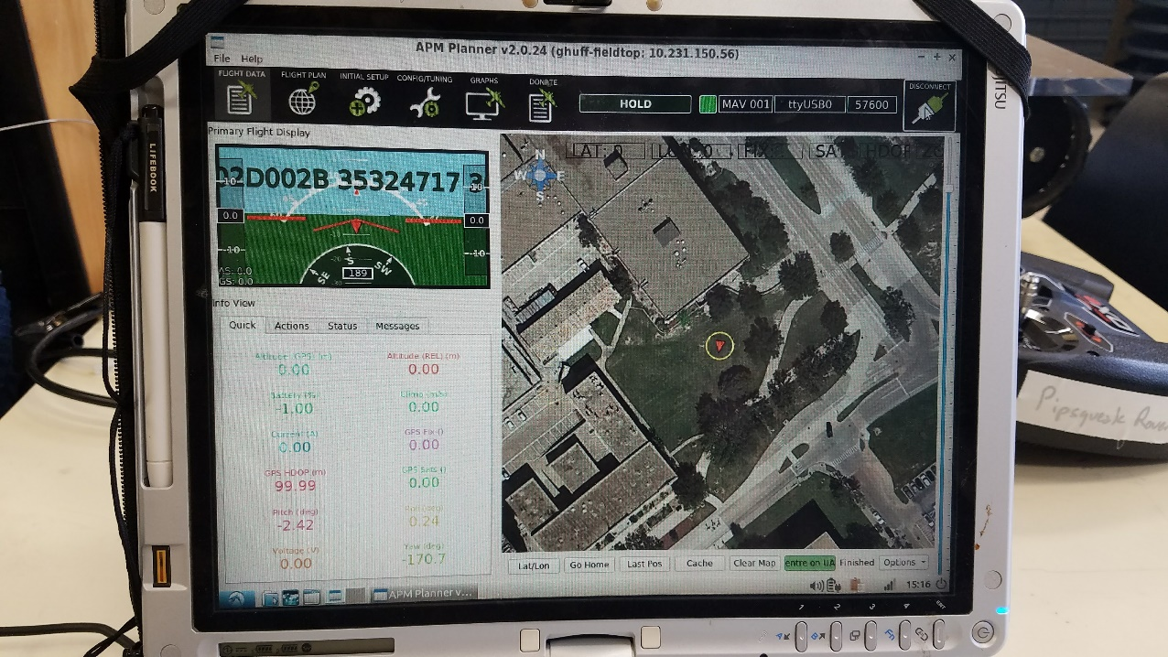

Figure : Laptop Setup

1. Connect to the pixhawk using a baud rate of 57600 on APM Planner. A screenshot is shown in Figure 4. The “connect” button is marked with a red box.

Figure : Connect on APM Planner

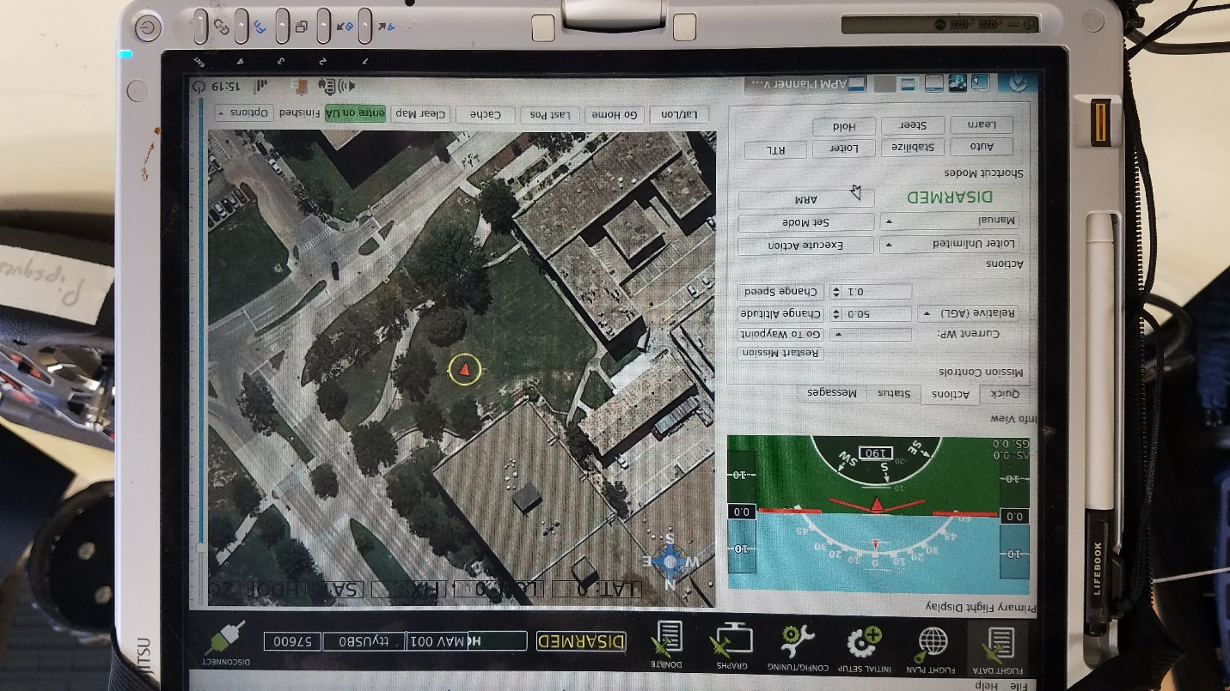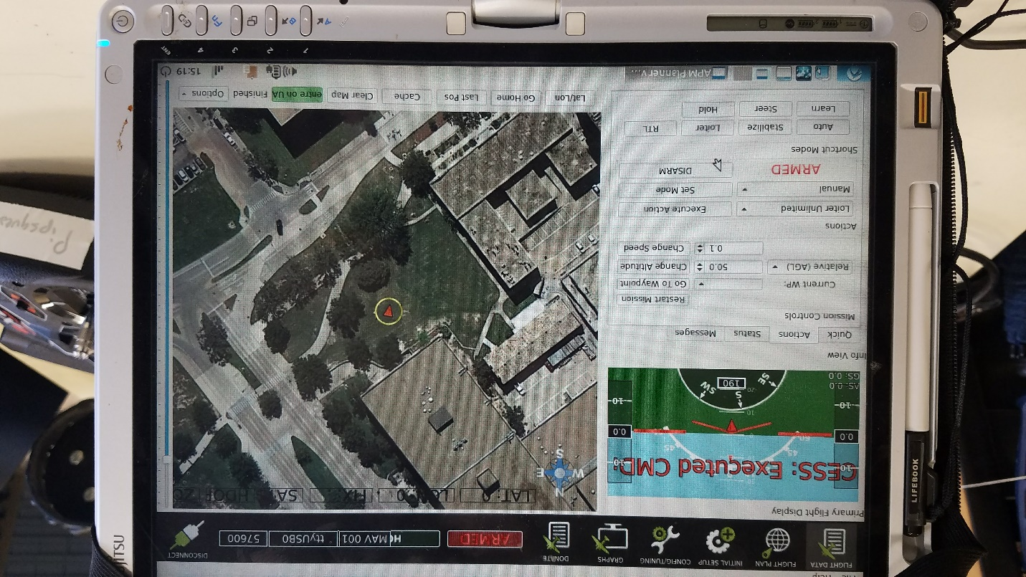

1. Arm the rover using the arming switch identified in Figure 1. Hold down the button until the LED stays red.
2. Arm the rover through APM planner under the “Actions” tab. The screen should look as portrayed in Figure 5.

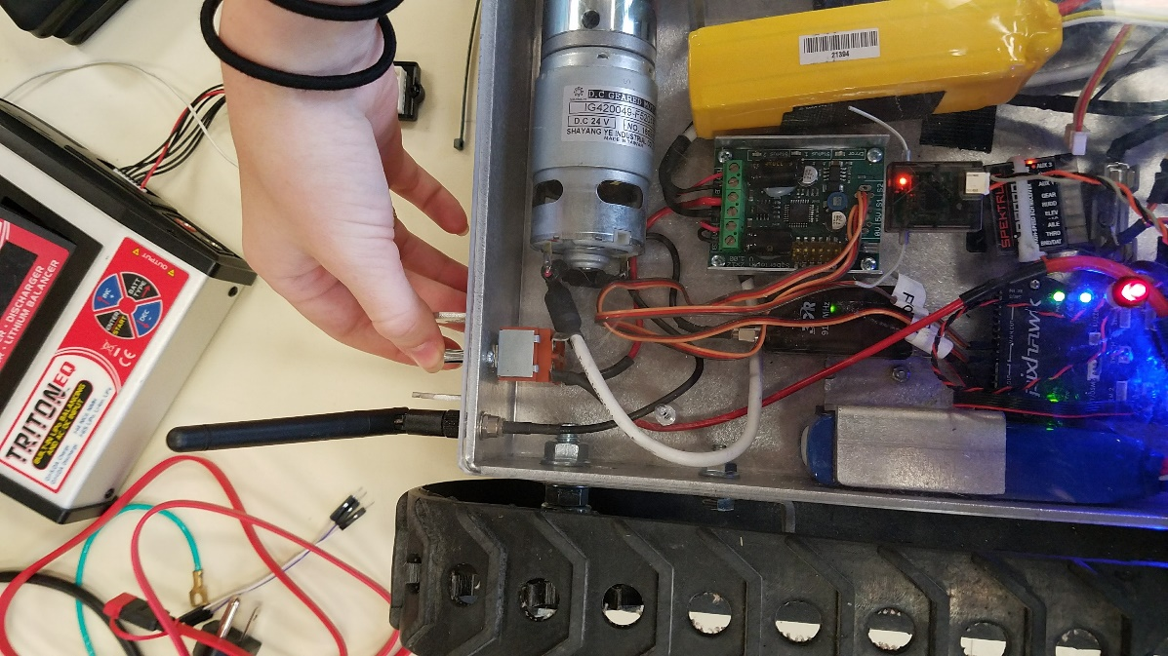

Figure 6: Flip the Motor Switch

Figure 5: Arming on APM Planner

1. Flip the motor switch to give power to the rover motors. Its location is shown in Figure 6.
2. Sometimes, the rover will start working at this point. Test it by moving the joysticks on the transmitter. If not, continue through the following steps.
3. Turn off the rover motor switch, disconnect from APM planner using the same button from Figure 4, and unplug the control battery (yellow) from Figure 1.
4. Plug the control battery back in. Ensure none of the pixhawk connectors are disconnected during this process.
5. Reconnect with APM planner as in Step 5. Arm the rover using the switch as in Step 6 and also arm through APM planner as in Step 7.
6. Turn on the rover motor switch again. The rover should start working this time. Sometimes, it just requires repetition. The left joystick on the transmitter should control the forward and backwards motion of the rover, while the right joystick makes the rover turn left or right.

To see a movie demonstrating the operation of the rover, please visit the following link: <https://drive.google.com/file/d/16GFnvYnByVB6qQcTpwRAcHbPGQQjQR_H/view?usp=sharing>